This assessment is there for you to check what you have learned both at school and during the Help Your Kids: Maths live lessons. Try and answer the question by yourself at first and once you have had a go try and get some help from your parents or even by watching the Lockdown lesson for that topic.

**ARITHMETIC SECTION**

1. **Mental Arithmetic**
2. **5 + 2 = ______________________**
3. **37 + 5 = ______________________**
4. **10 + 20 = ______________________**
5. **18 – 8 = ______________________**
6. **88 – 4 = ______________________**
7. **½ of 16 = ______________________**
8. **3 x 10 = ______________________**
9. **7 x 2 = ______________________**
10. **100 – 10 = ______________________**
11. **3 + 30 + 4 = ______________________**

**(10 Marks)**

**2) Partitioning Addition (3 Marks) a) 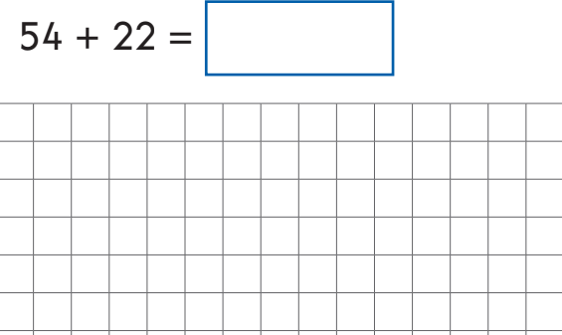 b) 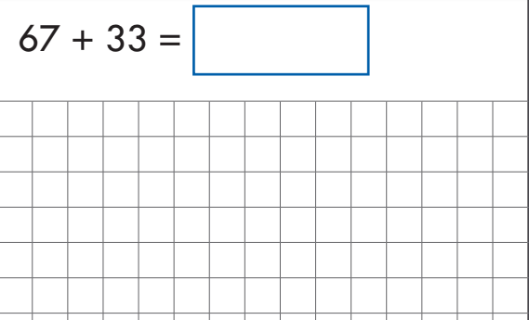 c)**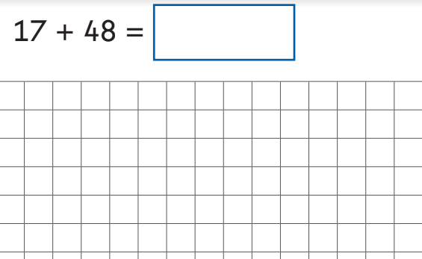

**3) Written Subtraction**

**a)**

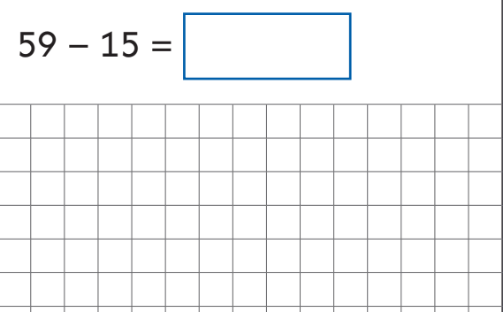

**b)**

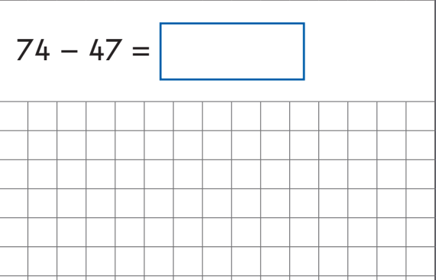

**(2 marks)**

**4. Harder Problems (4 marks)**

**a) Find ¼ of 24**

**_________________**

**b) 120 ÷ 10**

**_________________**

**c)**

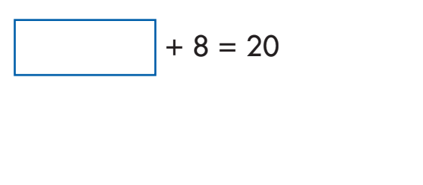

**d)**

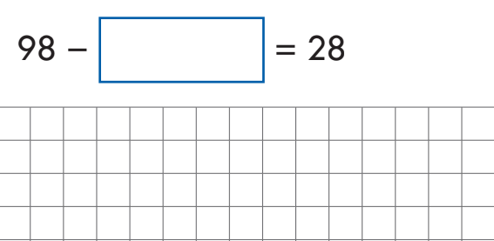

**PROBLEM SOLVING SECTION**

**1.**

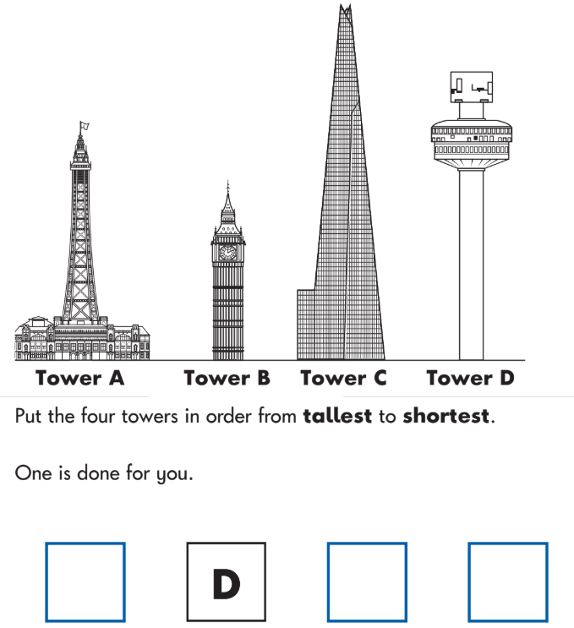

**(1 mark)**

1. **Name the two shapes in this picture…**

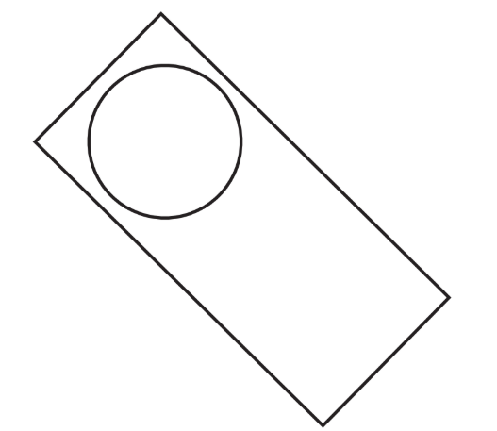 **(2 (2 marks)**

**SHAPE 2: ________________________**

**SHAPE 1: ________________________**

**3.**

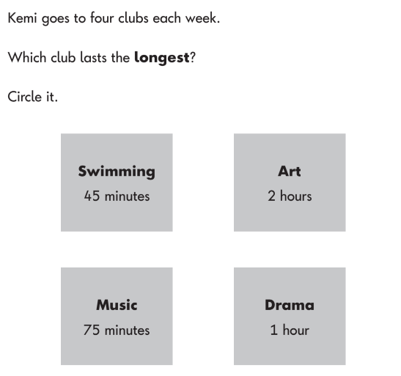**(1 mark)**

**4.**

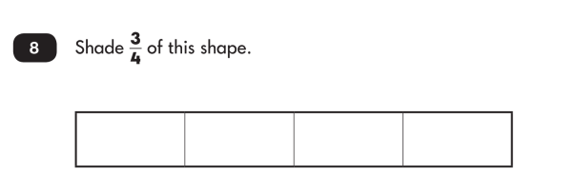**(1 mark)**

**5.**

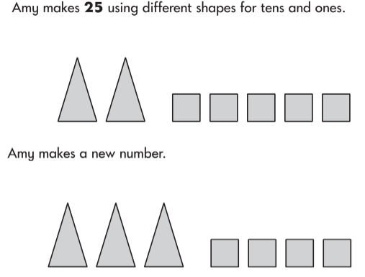

**What is Amy’s new number? ________________ (1 mark)**

**6. 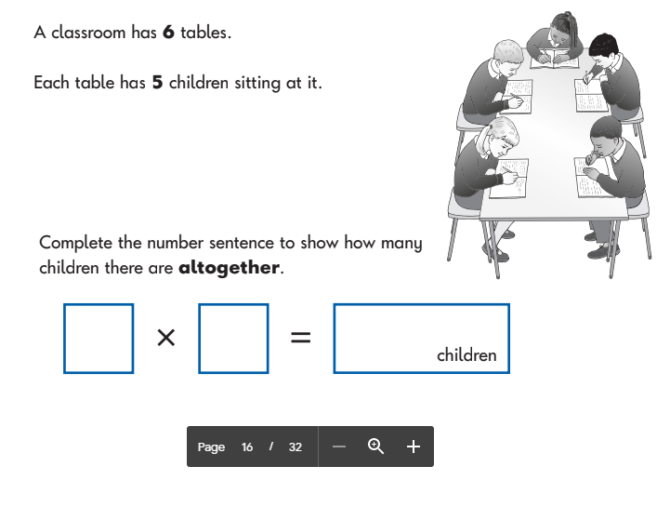(1 mark)**

**7. a)**

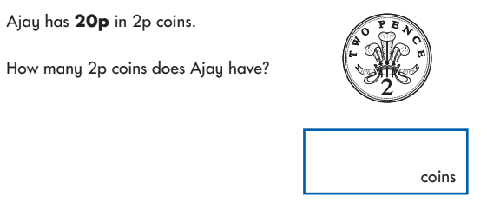**(1 mark)**

**b) Ajay buys a chocolate bare that costs 85p. He pays with a £1 coin. How much change does he get?**

**________________ (1 mark)**

**8.**

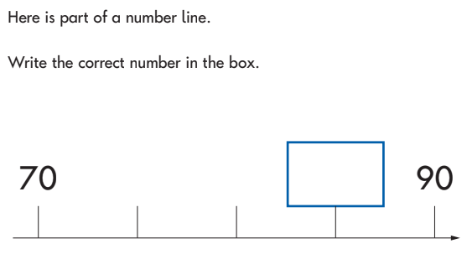 **(1 mark)**

**9.**

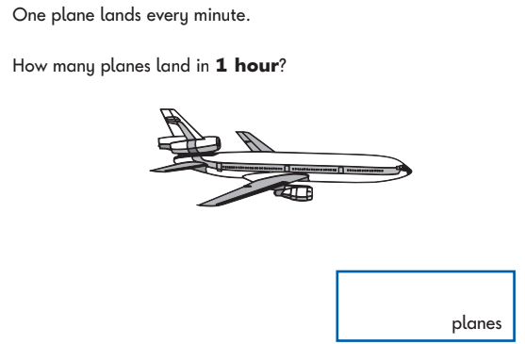 **(1 mark)**

**10.**

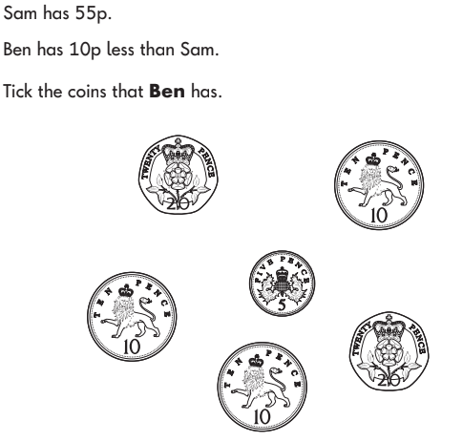**(1 mark)**

**11.**

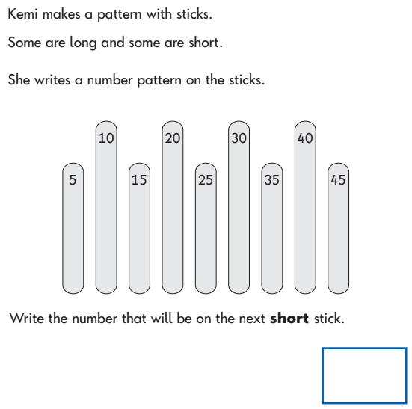**(1 mark)**

**12.**

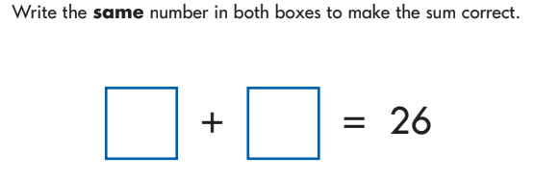**(1 mark)**

**13.**

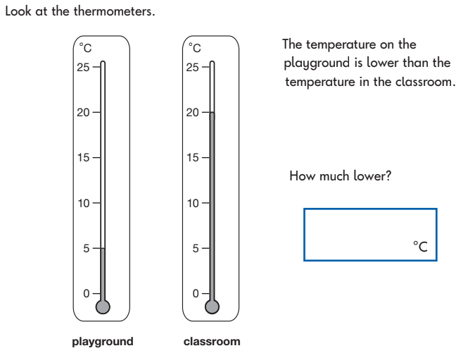**(1 mark)**

**14. Draw a rectangle that is 7cm long and 3cm wide. Use a ruler.**

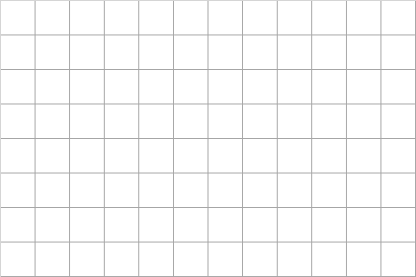 **(1 mark)**

**15.**

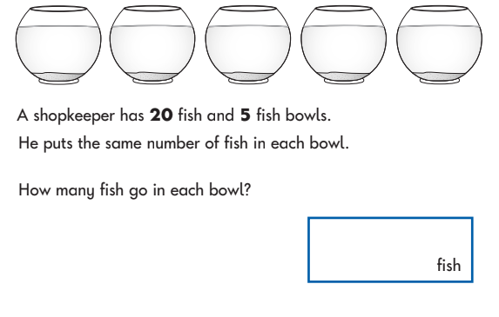 **(1 mark)**

**16.**

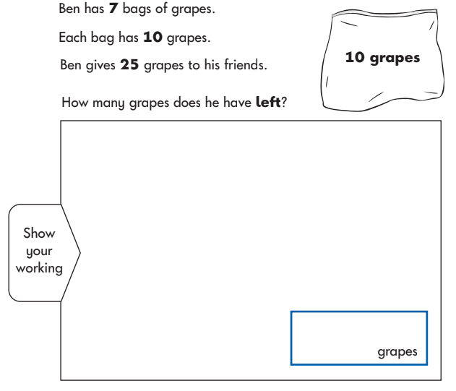**(2 marks)**