This assessment is there for you to check what you have learned both at school and during the Help Your Kids: Maths live lessons. Try and answer the question by yourself at first and once you have had a go try and get some help from your parents or even by watching the Lockdown lesson for that topic.

**1.**

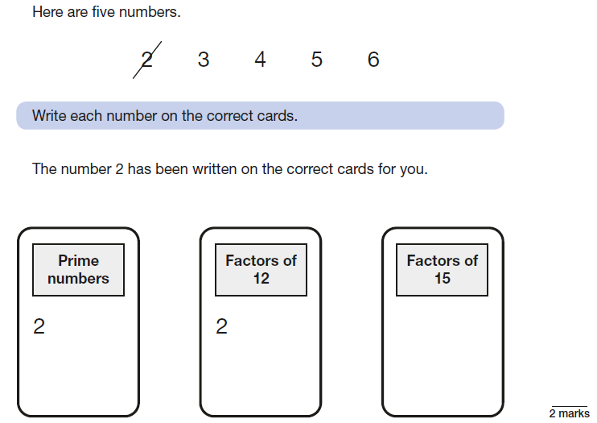

**2.** 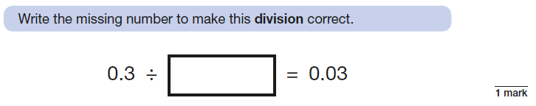

**3. a)** Work out of 35



**b)** Work out of 36

**4.**

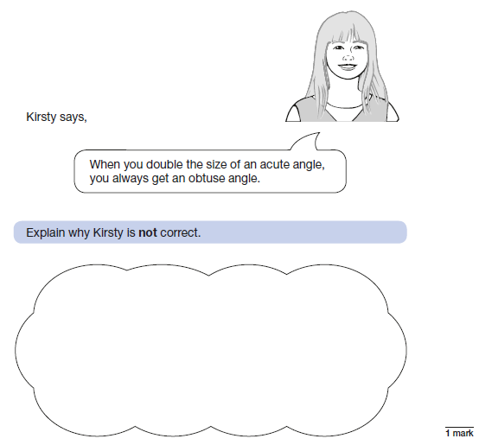

**5. a)** Work out 25.34 x 10



**b)** Work out 7 + 3 x 4



**c)** Work out 24 ÷ (13 – 7)



**6. Look at the two clocks below…**

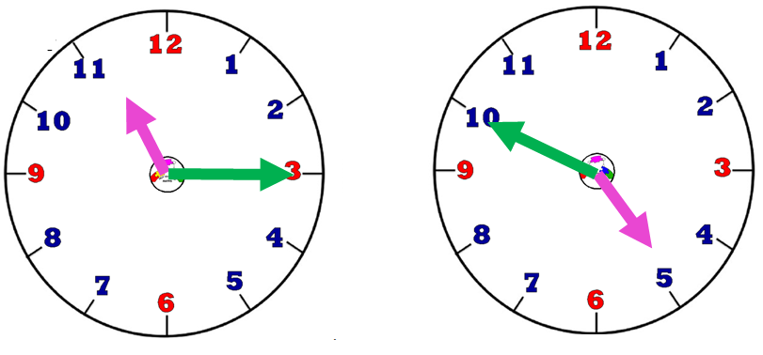

What is the difference between the two times? Give your answer in hours and minutes.



**7.** a) Work out 264 + 387



1. Work out 264 – 183



**8.** 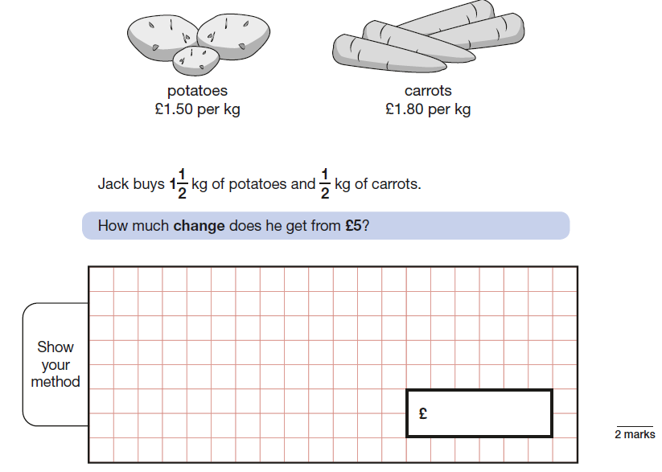

**9.** 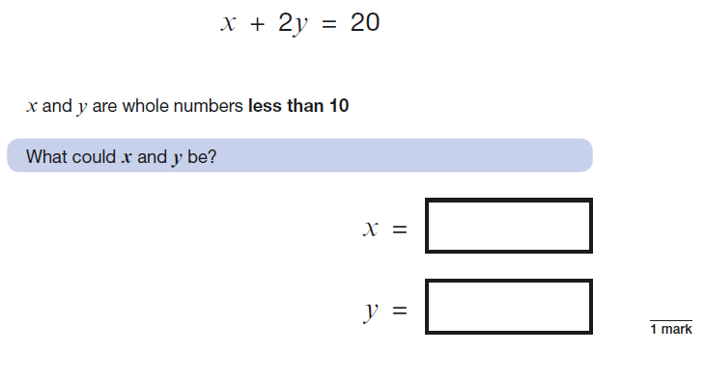

**10.** 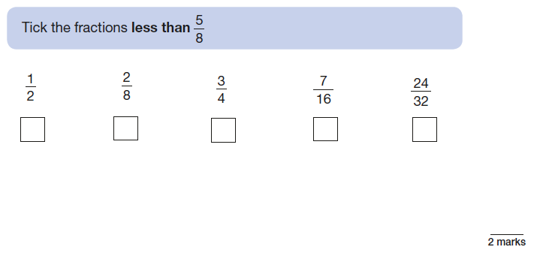

11. 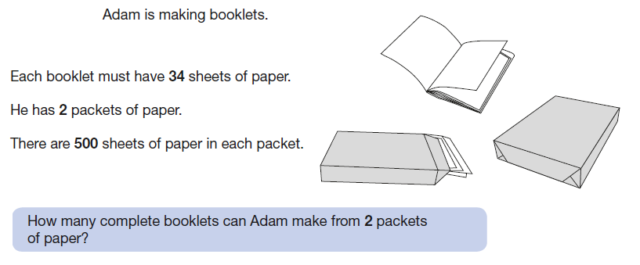

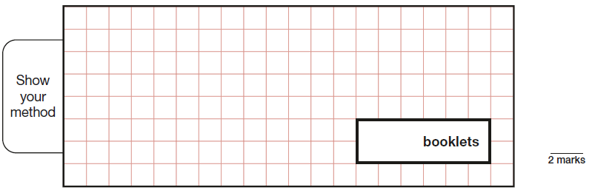

**12.** a) Work out 34 x 6

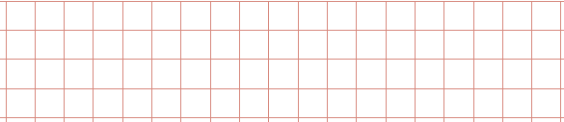

b) Work out 479 ÷ 3



c) Work out 58 x 24



d) Work out 782 ÷ 17



**(8 marks)**

**13.** 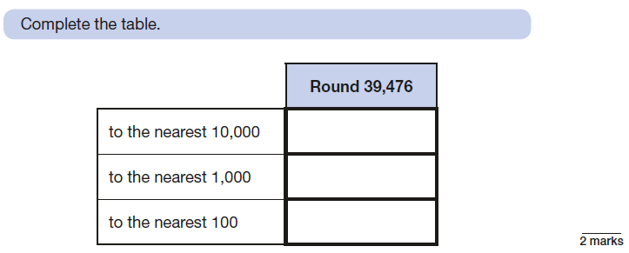

**14.** 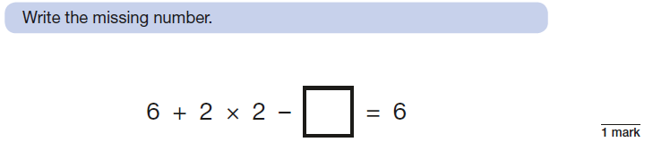

**15.** 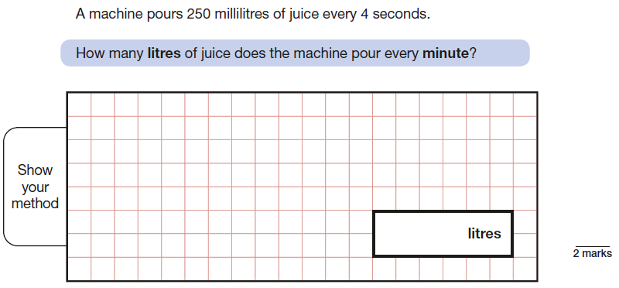

**16.** a) Find 25% of £48

(1 mark)

b) Find 30% of £82

(2 marks)

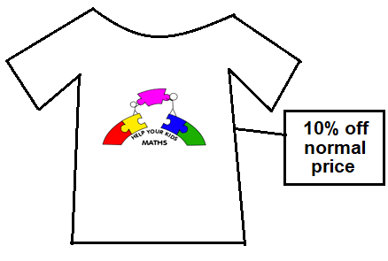c) A T-shirt normally costs £24.

It is in a sale saying 10% off.

How much does it cost in the sale?

(2 marks)

**17.** Find the size of the angle marked ***x***. The diagram is **NOT** drawn accurately.

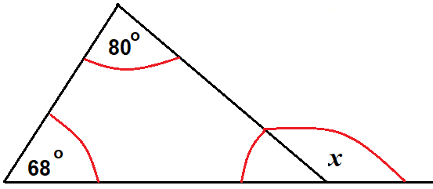



**18.**

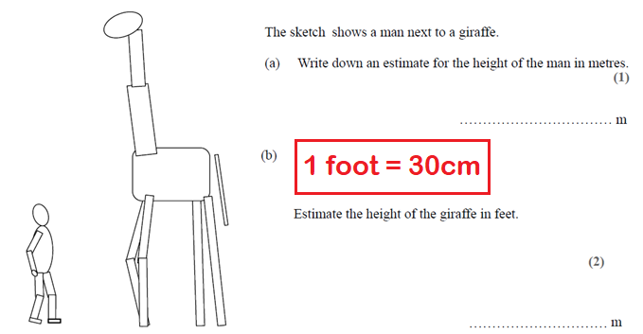

**19.**

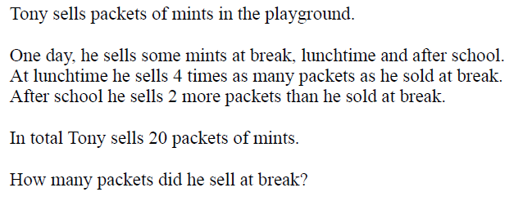

**(3 marks)**